LIMIT ORDERS by CUSTOMER’S USER ID

Order Entry and Order Inquiry can now limit what orders display for specific customers by User ID.

A customer service rep will only be able to ADD or VIEW orders for their customers.

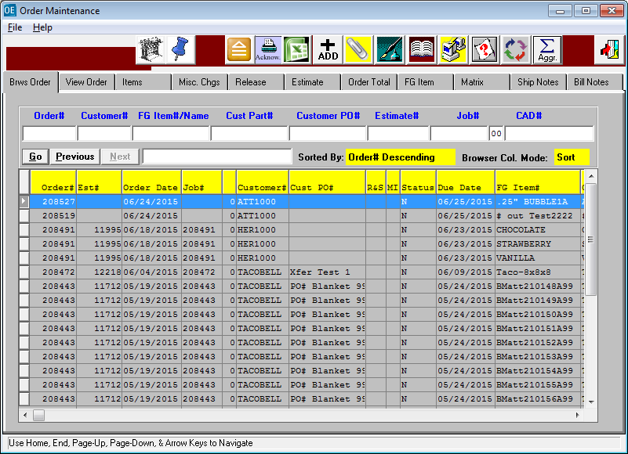

LIMIT ORDERS by CUSTOMER’S USER ID

Order Entry and Order Inquiry can now can be limited to specific customers by User ID.

Now a customer service rep will only be able to ADD or VIEW orders for their customers.

The N-K-1 CustomerList. View Form Character Value = OU1  Logical Value must = YES.

The N-K-1 CustomerList. View Form Character Value = OQ1  Logical Value must = YES.

First Step is to define the Customers in the Users File under system administration. N-U

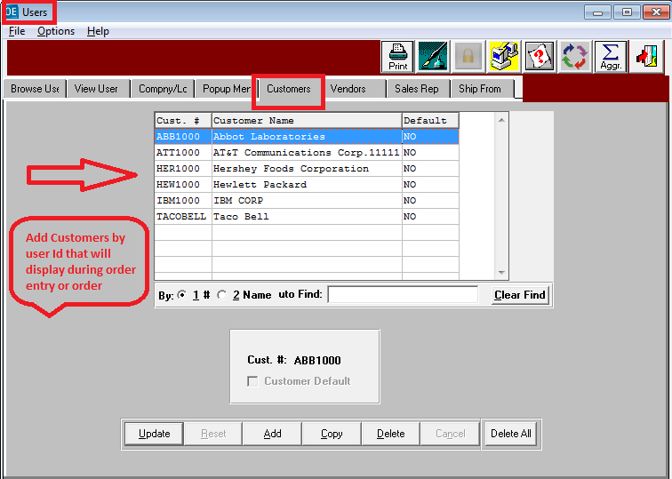

LIMIT ORDERS by CUSTOMER’S USER ID

Click N-K-1 and Find the CustomerList Parameter.

Find the Business Form OU1 and check the logical value toggle box.

This will only display customers by customer server reps User Id during order entry.

This will also prevent adding orders for another user id’s customer.

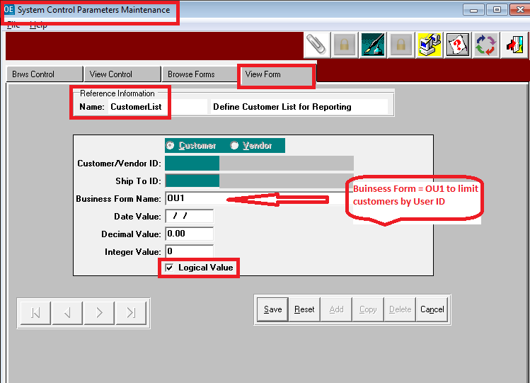

LIMIT ORDERS by CUSTOMER’S USER ID

Click N-K-1 and Find the CustomerList Parameter.

Find the Business Form OQ1 and check the logical value toggle box.

This will only display orders for customers by customer server reps User Id during order inquiry.

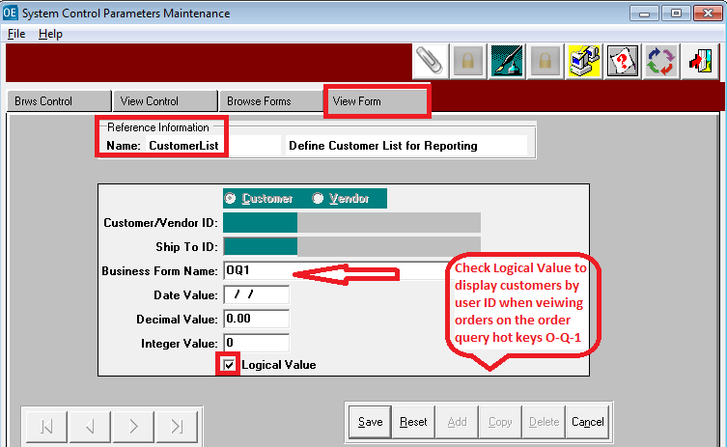

LIMIT ORDERS by CUSTOMER’S USER ID

Defining Customers for Specific User ID.

1. Set N-K-1 CustomerList Logical Value = Yes
2. Set N-K-1 CustomerList View Form  Logical Value = Yes and customer Code = Blank.
3. For each User Id, click he Customers Tab and Select Customers

